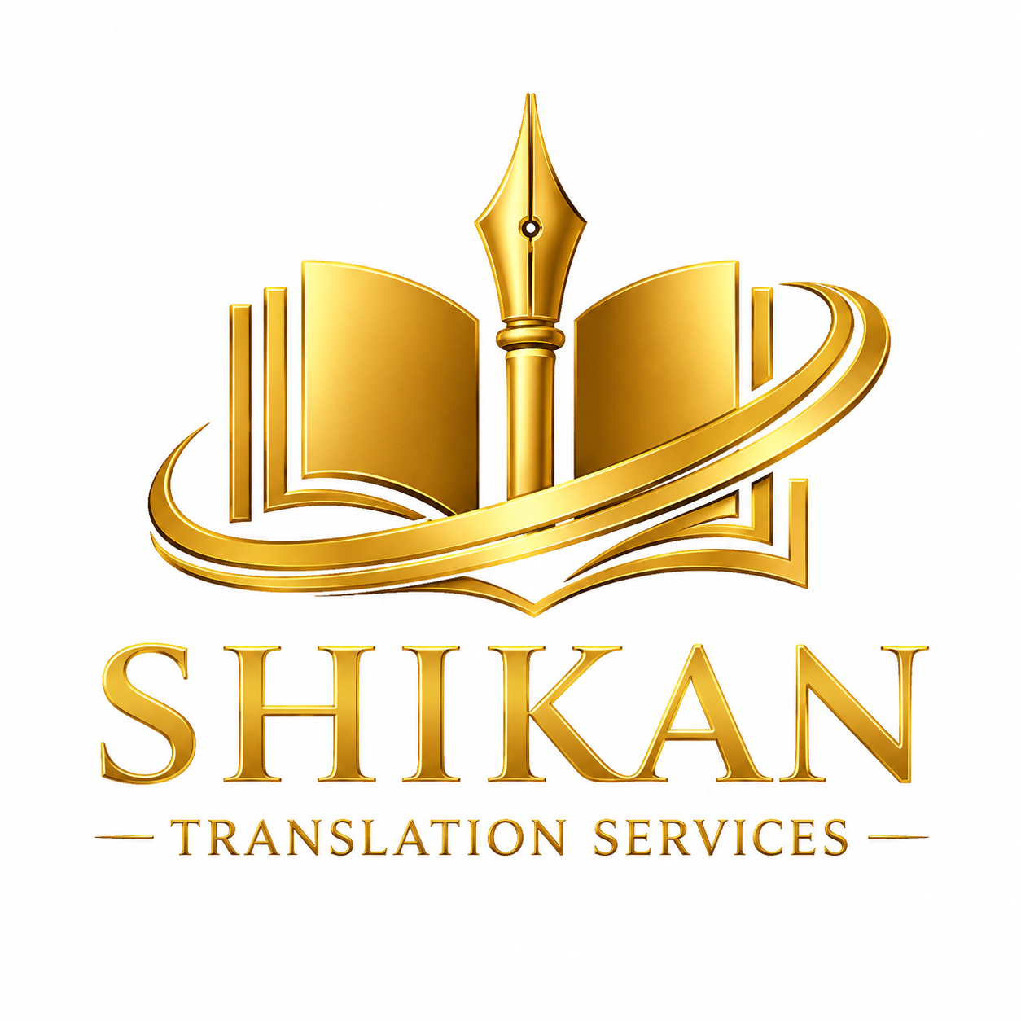

Shikan Translation Services (STS) - Corporate Profile
GLOBAL CREDIBILITY. PROFESSIONAL EXCELLENCE.

Company Overview
Professional translation, localization and multilingual communication services for embassies, UN agencies, NGOs, government institutions, universities and corporate clients.
Shikan Translation Services (STS) is a premium language solutions provider headquartered in Kigali, Rwanda. We deliver authenticated, high-quality translation, localization, and multilingual communication services that bridge linguistic and cultural gaps for international organizations, diplomatic missions, development agencies, academic institutions, and businesses operating across borders.
Our client portfolio includes embassies, UN agencies, NGOs, government institutions, universities, and corporate clients who trust us with their most critical communications.

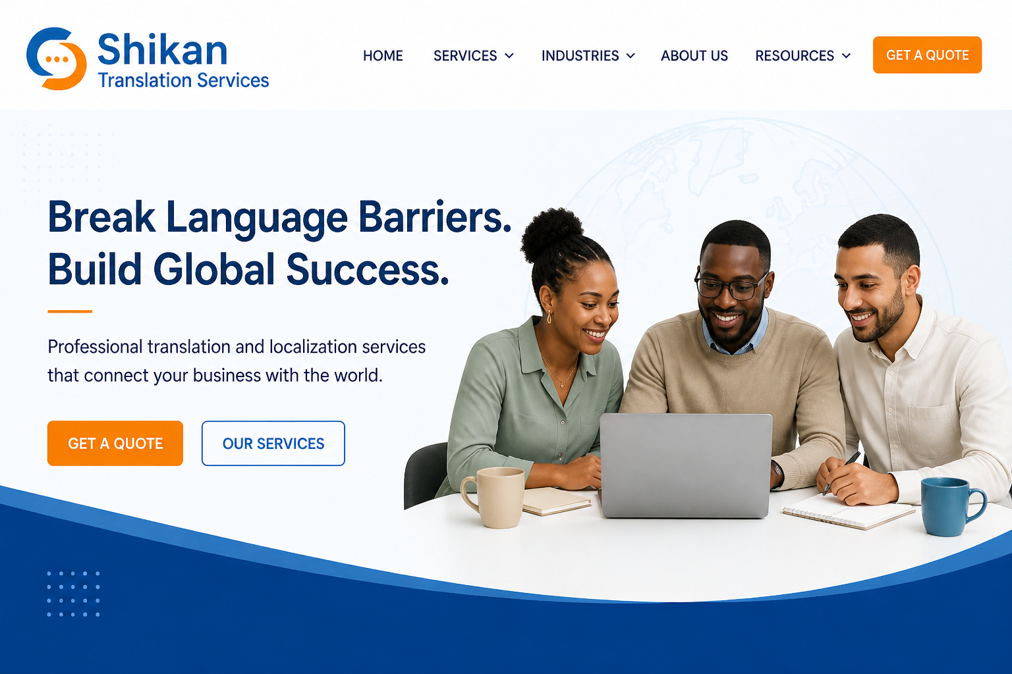

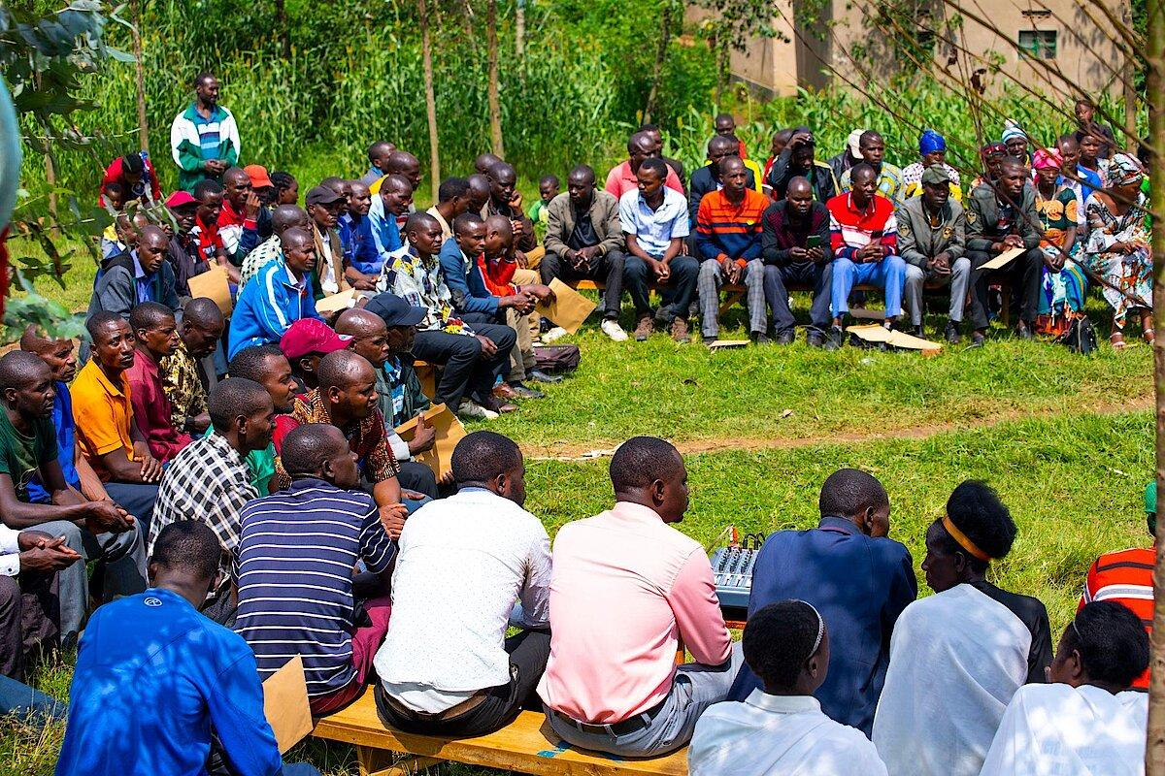

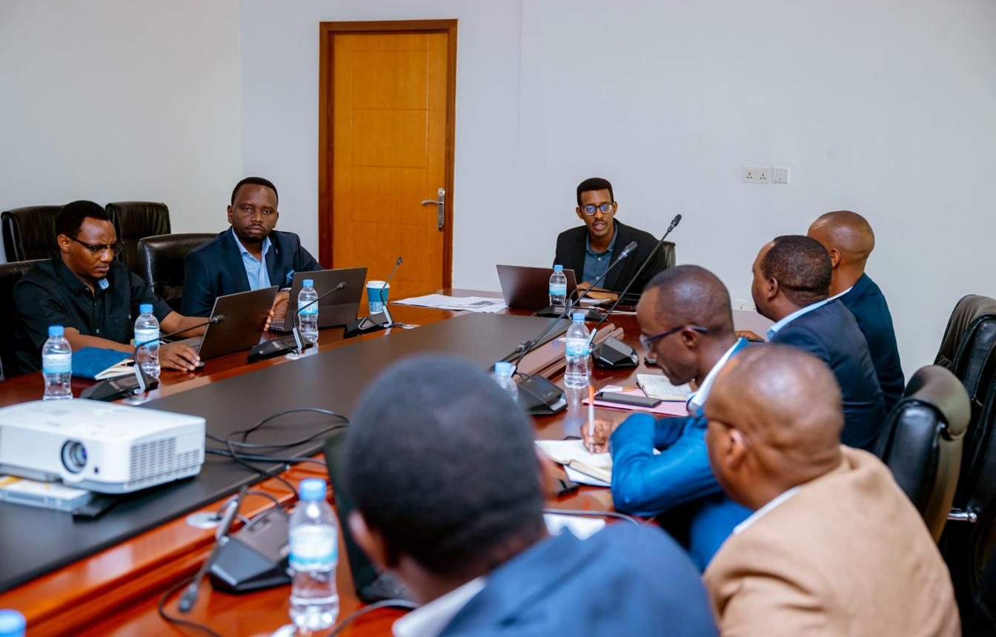

Our Services
Document Translation, Technical Translation, Academic Translation, Legal Translation, Administrative Translation, Business Translation, Technical Translation, IT Translation, Legal Translation. Localization, Proofreading & Editing, Business Translation, Multilingual Communication Support.

Founder Bio
Eltigani A. Musa

Executive Founder Biography
(Recommended for the STS Corporate Profile)

Eltigani Abdelgabar Musa Abdalla
Founder & Managing Director
Shikan Translation Services (STS)
Eltigani Abdelgabar Musa Abdalla is a Sudanese language professional, translator, researcher, and entrepreneur with more than twenty years of international professional experience in translation, multilingual communication, information technology, and cross-cultural engagement.
He holds a Master of Science (MSc) in Management Information Systems and has completed specialized professional translation training through New York University. He is currently pursuing a PhD, reflecting his ongoing commitment to academic excellence, research, and professional development.
Throughout his career, Mr. Musa served for more than two decades at the Embassy of the State of Qatar in Tokyo, where he gained extensive experience in diplomatic communication, intercultural relations, administration, and multilingual professional services within an international environment.
A former member of the American Translators Association and the World Association of Arab Translators and Linguists, Mr. Musa has dedicated his professional life to facilitating accurate communication across languages and cultures. His working languages are Arabic and English, with extensive experience supporting international stakeholders, institutions, and multicultural audiences.
In addition to his professional activities, he is the author of the forthcoming book Sudan: Engineered Collapse, an analytical study examining the political, economic, and governance factors that have shaped Sudan's modern history.
As Founder and Managing Director of Shikan Translation Services (STS), Mr. Musa leads the organization's mission to provide high-quality translation, localization, interpretation, and language consulting services that meet international standards of professionalism, accuracy, confidentiality, and cultural sensitivity.

Why Choose STS

✓ Authenticated Academic Credentials
All academic and professional qualifications have been officially verified through relevant institutions and authorities.

✓ International Training
Specialized education from world-leading programs in translation, interpreting, and information systems.

✓ 20+ Years of Experience
Deep expertise spanning translation, information technology, and international communication sectors.

✓ Confidentiality
Strict data protection protocols and non-disclosure agreements safeguarding all client materials.

✓ Quality Assurance
Multi-layered review processes ensuring accuracy, consistency, terminology precision, and cultural appropriateness.

✓ Professional Excellence
Unwavering commitment to the highest standards of linguistic accuracy, ethical practice, and client satisfaction.

Industries Served

INDUSTRIES SERVED
◆ Embassies — Diplomatic correspondence, treaties, consular documents, and official communications.
◆ UN Agencies — Reports, resolutions, policy documents, and multilingual institutional documentation.
◆ NGOs — Project proposals, impact assessments, advocacy materials, and community engagement content.
◆ Government Institutions — Legislation, policy documents, public communications, and administrative materials.
◆ Universities — Academic papers, research publications, educational content, and institutional communications.
◆ International Organizations — Conference materials, bilateral agreements, and cross-border communications.
◆ Corporate Clients — Marketing collateral, legal documents, technical manuals, and business communications.

CONTACT
Shikan Translation Services (STS) Kigali, Rwanda
📧 Email: [shikantranslation@gmail.com, info@shikantranslation.com] 🌐 Website: [www.shikantranslation.com] 📱 Phone: [+250 795798898] 💼 LinkedIn: [linkedin.com/company/shikan-translation-services]

GLOBAL CREDIBILITY. PROFESSIONAL EXCELLENCE.

